Power BI Portfolio
  - Exploratory analysis of UK road traffic accidents (2005-2015)
Tools: Power BI • Power Query • DAX
Dataset: UK STATS19 Road Safety Data
Records: 2 million accidents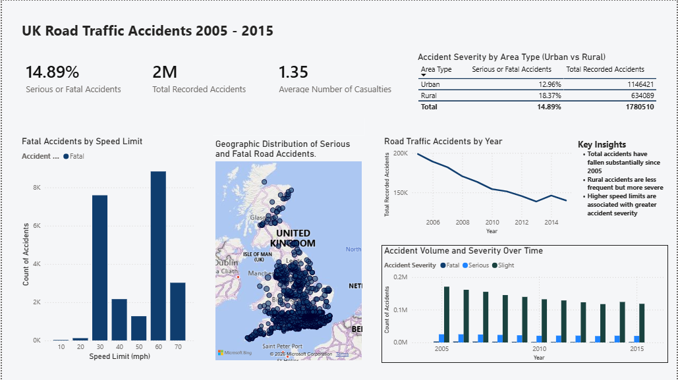

  - Project Overview
- Cleaned and transformed multi-year accident data using Power Query
- Decoded categorical variables (severity, weather, lighting, road conditions)
- Created DAX measures for accident counts and severity percentages
- Designed an executive-style dashboard focused on trends and risk factors
  - Key Insights
- Serious or fatal accidents account for 15% of all recorded incidents
- Overall accident volume declined steadily between 2005 and 2015
- Rural accidents are less frequent but more severe than urban accidents
- Higher speed limits are associated with increased accident severity

